**CC-215-L: Database Systems Lab**

*Faculty of Computing & Information Technology*



**BS(CS) Morning - Fall 2021, Semester Fall 2023**

**LAB – 10**

# Topics

* PL/SQL Basics
* I/O
* Variables
* SELECT
* IF
* LOOP
* EXCEPTIONS.

# General Instructions:

* In this Lab, you are **NOT** allowed to discuss your solution with your colleagues, even not allowed to ask how s/he is doing; this may result in negative marking. You can **ONLY** discuss with your Teaching Assistants (TAs) or Lab Instructor.
* Your TAs will be available in the Lab for your help. Alternatively, you can send your queries via email to one of the followings.

|  |  |  |
| --- | --- | --- |
| **Lab Instructors** | | |
| Course Instructor | Dr. Asif Sohail | [asif@pucit.edu.pk](mailto:asif@pucit.edu.pk) |
| Teaching Assistants | Kabeer Ali | [bitf20m018@pucit.edu.pk](mailto:bitf20m018@pucit.edu.pk) |
| Hamza Farooqi | [bitf20m031@pucit.edu.pk](mailto:bitf20m018@pucit.edu.pk) |

Hope you are fine and feeling yourself comfortable and exciting to play with Structured Query Language (SQL) in this first lab. *You have been taught in the lecture about SQL and query writing. Why not to get all what you have learned with a hands-on experience?* So, let’s Start!

*Allowed time: 1.5 hour*

***Note: Do follow these instructions while you are sitting in the lab and performing the tasks.***

1. ***Gossips are not allowed. So be gentle and do what you know. The lab is not to deduct your sessional marks but to prepare you to achieve good marks in quizzes, mids and finals and finally have good grades. So, try to perform all your tasks in time and at your own.***
2. ***Teacher assistants are for your help, so be nice with them. Respect them as they are teaching you. Raise your hands if you have some problem and need help from TA. Avoid calling them by raising your voice and disturbing the environment of Lab.***
3. ***You must revise the content of the past lectures before starting the lab, it will help you resolve most of your general queries and give you the confidence that you can do it.***
4. ***Evaluation will be considered final and you cannot debate for the marks. So, focus on performing the tasks when the time is given to you.***
5. ***TA may deduct your marks for any kind of ill-discipline or misconduct from your side.***
6. ***Finally, pray before you start. And, Best of Luck!***

* **Kindly paste the query as well as result table screenshot as a result of each task**

**Sample:**

**Display All the Employees from emp table**

**Solution:**

**Select * from emp**

|  |  |  |  |  |  |  |  |
| --- | --- | --- | --- | --- | --- | --- | --- |
| **EMPNO** | **ENAME** | **JOB** | **MGR** | **HIREDATE** | **SAL** | **COMM** | **DEPTNO** |
| 7369 | SMITH | CLERK | 7902 | 12/17/1980 | 800 | - | 20 |
| 7499 | ALLEN | SALESMAN | 7698 | 02/20/1981 | 1600 | 300 | 30 |
| 7521 | WARD | SALESMAN | 7698 | 02/22/1981 | 1250 | 500 | 30 |
| 7566 | JONES | MANAGER | 7839 | 04/02/1981 | 2975 | - | 20 |
| 7654 | MARTIN | SALESMAN | 7698 | 09/28/1981 | 1250 | 1400 | 30 |

**Task 01: [30 Marks]**

1. Write a PL/SQL block that receives the Name roll number and cgpa from the user and displays the Data.

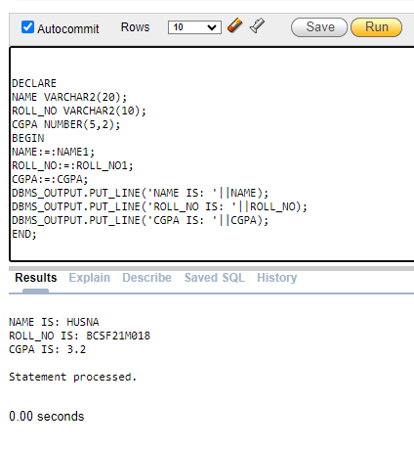 (2)

1. Write a PL/SQL block that prompts the user to input a department name. Retrieve and display the count of employees working in that department. Handle the exception of "NO_DATA_FOUND" if the department does not exist. (3)

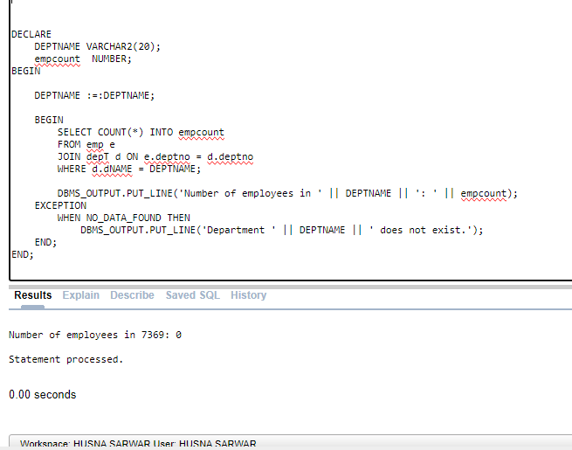

1. Suppose that salary of an employee is raised annually as per the following rules: (5)

|  |  |
| --- | --- |
| **JOB** | **INCREMENT % OF SAL** |
| CLERK | 20 |
| SALESMAN | 15 |
| MANAGER | 10 |
| ANALYST | 5 |
| OTHERS | 0 |

Write a PLSQL program that takes the empno of an employee and find the number of year after which the sal of employee will get the double of their current sal. The raise in sal is applied annually according to the respective sal of that year.

DECLARE

EMPNUM EMP.EMPNO%TYPE;

ENAME EMP.ENAME%TYPE;

SAL EMP.SAL%TYPE;

JOB EMP.JOB%TYPE;

YCOUNT NUMBER(2):= 0;

TSAL EMP.SAL%TYPE;

BEGIN

EMPNUM:=:EMPNUM;

SELECT ENAME,JOB,SAL INTO ENAME,JOB,SAL FROM EMP WHERE EMPNUM = EMPNO;

DBMS_OUTPUT.PUT_LINE('NAME = '||ENAME);

DBMS_OUTPUT.PUT_LINE('ORIGINAL SALARY = '||SAL);

DBMS_OUTPUT.PUT_LINE('JOB = '||JOB);

TSAL:=SAL*2;

WHILE SAL<TSAL LOOP

CASE JOB

WHEN 'CLERK' THEN SAL:=SAL+(SAL*0.20);

WHEN 'SALESMAN' THEN SAL:=SAL+(SAL*0.15);

WHEN 'MANAGER' THEN SAL:=SAL+(SAL*0.1);

WHEN 'ANALYST' THEN SAL:=SAL+(SAL*0.05);

ELSE SAL:=SAL;

END CASE;

YCOUNT:= YCOUNT+1;

END LOOP;

DBMS_OUTPUT.PUT_LINE('YEARS TO DOUBLE THE SALARY = '||YCOUNT);

END;

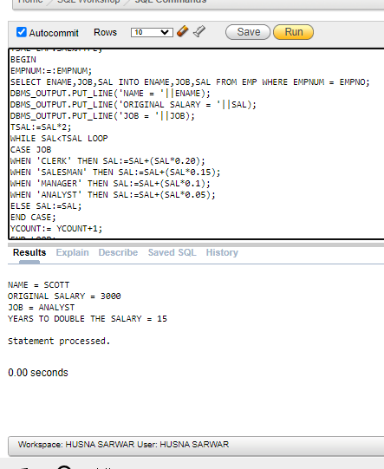

3.Write a PL/SQL program that receives a string from the user, checks if the string is a palindrome, and displays an appropriate message along with the original string. (5)

1. Write a PL/SQL program that retrieves the number of years an employee has been with the company and increases their salary by a certain percentage based on their experience: (5)

Less than 2 years: 5%

2 to 5 years: 10%

More than 5 years: 15%

Display the updated salary along with the experience and the percentage increase

DECLARE

EMPNUM EMP.EMPNO%TYPE;

ENAME EMP.ENAME%TYPE;

HIREDATE EMP.HIREDATE%TYPE;

EXPERIENCE NUMBER(5);

SAL EMP.SAL%TYPE;

PERCENTAGE NUMBER(5,3);

BEGIN

EMPNUM:=:EMPNUM;

SELECT ENAME,HIREDATE,SAL INTO ENAME,HIREDATE,SAL FROM EMP WHERE EMPNUM = EMPNO;

SELECT TRUNC(MONTHS_BETWEEN(SYSDATE,HIREDATE)/12) INTO EXPERIENCE FROM EMP WHERE EMPNUM = EMPNO;

DBMS_OUTPUT.PUT_LINE('EXPERIENCE = '||EXPERIENCE);

DBMS_OUTPUT.PUT_LINE('ORIGINAL SALARY = '||SAL);

IF EXPERIENCE < 2 THEN

PERCENTAGE:= 0.05;

SAL:= SAL+(SAL*PERCENTAGE);

DBMS_OUTPUT.PUT_LINE('PERSENTAGE INCREASE: = '||PERCENTAGE);

ELSIF EXPERIENCE BETWEEN 2 AND 5 THEN

PERCENTAGE:= 0.10;

SAL:= SAL+(SAL*PERCENTAGE);

DBMS_OUTPUT.PUT_LINE('PERSENTAGE INCREASE: = '||PERCENTAGE);

ELSE

PERCENTAGE:= 0.15;

SAL:= SAL+(SAL*PERCENTAGE);

DBMS_OUTPUT.PUT_LINE('PERSENTAGE INCREASE: = '||PERCENTAGE);

END IF;

DBMS_OUTPUT.PUT_LINE('UPDATED SALARY = '||SAL);

END;

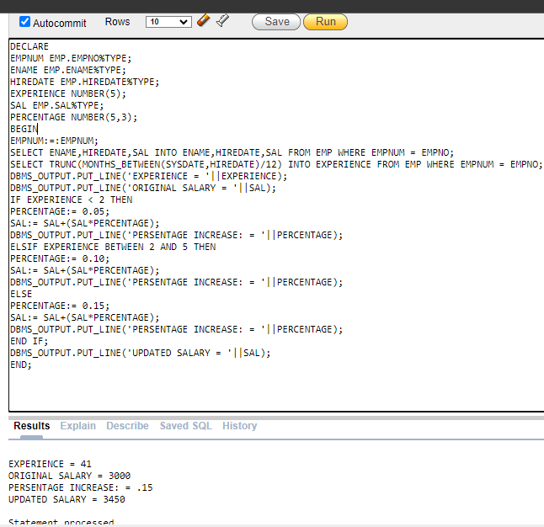

1. Write a PL/SQL program that compares the salary of an employee with the average salary in their department. The program should prompt the user to input an employee number, retrieve the employee’s salary and the average salary in their department, and display a message indicating whether the employee’s salary is above, below, or equal to the average salary in their department. (5)

DECLARE

EMPNUM EMP.EMPNO%TYPE;

ENAME EMP.ENAME%TYPE;

SAL EMP.SAL%TYPE;

JOB EMP.JOB%TYPE;

AVERAGE EMP.SAL%TYPE;

BEGIN

EMPNUM:=:EMPNUM;

SELECT ENAME,JOB,SAL INTO ENAME,JOB,SAL FROM EMP WHERE EMPNUM = EMPNO;

SELECT ROUND(AVG(SAL), 2)

INTO AVERAGE

FROM EMP

WHERE DEPTNO = DEPTNO;DBMS_OUTPUT.PUT_LINE('NAME = '||ENAME);

DBMS_OUTPUT.PUT_LINE('ORIGINAL SALARY = '||SAL);

DBMS_OUTPUT.PUT_LINE('JOB = '||JOB);

DBMS_OUTPUT.PUT_LINE('AVERAGE SALARY = '||AVERAGE);

IF SAL<AVERAGE THEN

DBMS_OUTPUT.PUT_LINE('SALARY '||SAL||' IS BELOW THE AVERAGE SALARY');

ELSIF SAL = AVERAGE THEN

DBMS_OUTPUT.PUT_LINE('SALARY '||SAL||' IS EQUAL TO THE AVERAGE SALARY');

ELSE

DBMS_OUTPUT.PUT_LINE('SALARY '||SAL||' IS ABOVE THE AVERAGE SALARY');

END IF;

END;

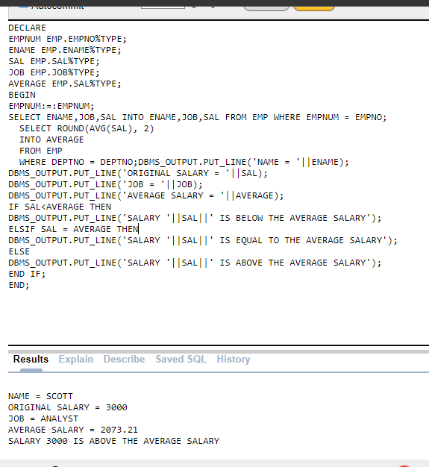

1. Write a PL/SQL program that displays the name of an employee in the following format: (4+1)

a)

S

M

I

T

H

DECLARE

EMPNUM EMP.EMPNO%TYPE;

ENAME EMP.ENAME%TYPE;

I NUMBER;

LEN NUMBER;

BEGIN

EMPNUM:=:EMPNUM;

SELECT ENAME INTO ENAME FROM EMP WHERE EMPNUM = EMPNO;

DBMS_OUTPUT.PUT_LINE('NAME = '||ENAME);

LEN:=LENGTH(ENAME);

FOR I IN 1..LEN LOOP

DBMS_OUTPUT.PUT_LINE(SUBSTR(ENAME,I,1));

END LOOP;

END;

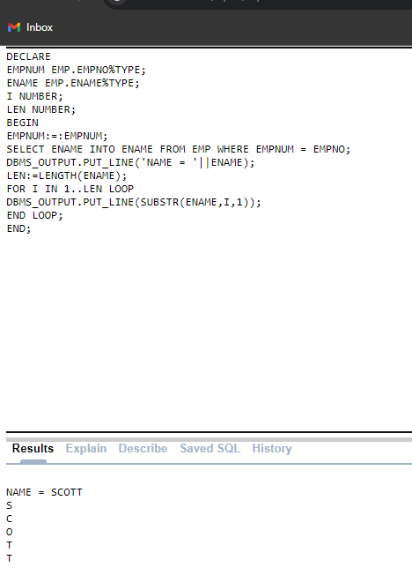

b)

S

*M

**I

***T

****H

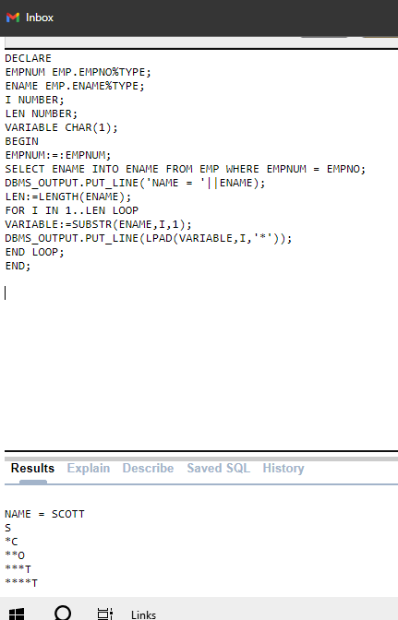

DECLARE

EMPNUM EMP.EMPNO%TYPE;

ENAME EMP.ENAME%TYPE;

I NUMBER;

LEN NUMBER;

VARIABLE CHAR(1);

BEGIN

EMPNUM:=:EMPNUM;

SELECT ENAME INTO ENAME FROM EMP WHERE EMPNUM = EMPNO;

DBMS_OUTPUT.PUT_LINE('NAME = '||ENAME);

LEN:=LENGTH(ENAME);

FOR I IN 1..LEN LOOP

VARIABLE:=SUBSTR(ENAME,I,1);

DBMS_OUTPUT.PUT_LINE(LPAD(VARIABLE,I,'*'));

END LOOP;

END;

1. Viva Voice (5)

**Task 02: Bonus Task [10 solid Marks]**

1. Display the name,empno,sal and dname of all employees in emp table using PLSQL Block use of cursor or other concepts that haven’t been studied are not allowd to use.

